A

Minor Project

On

**KEY LOGGER DETECTION**

(Submitted in partial fulfillment of the requirements for the award of Degree)

BACHELOR OF TECHNOLOGY

In

COMPUTER SCIENCE AND ENGINEERING

By

B.Varun kumar reddy (19E41A05K2)

A.Nikhil Kumar (19E41A05F1)

P.Bhargavi (18141A0526)

A.Uday Kiran Reddy (19E41A05J7)

Under the Guidance of

Mrs. P.Divya Sree

(Assistant professor)



**DEPARTMENT OF COMPUTER SCIENCE AND ENGINEERING**

**SREE DATTHA INSTITUTE OF ENGINEERING AND SCIENCE**

(Accredited by NAAC, Affiliated to JNTUH, Approved by AICTE, New Delhi)

Recognized Under Section 2(f) of the UGCAct.1956,

Sheriguda (V), Ibrahimpatnam (M), Ranga Reddy – 501510.

**2019-2023**

**DEPARTMENT OF COMPUTER SCIENCE AND ENGINEERING**



**CERTIFICATE**

This is to certify that the project entitled “**KEY LOGGERS DETECTION**” is being submitted by **B.VARUN KUMAR REDDY (19E41A05K2), A.NIKHIL KUMAR (19E41A05F1), P.BHARGAVI (18141A0526), A.UDAY KIRAN REDDY (19E41A05J7)** in partial fulfillment of the requirements for the award of the degree of B.Tech in Computer Science and Engineering to the Jawaharlal Nehru Technological University Hyderabad, is a record of bonafide work carried out by him/her under our guidance and supervision during the year 2022-23.

The results embodied in this thesis have not been submitted to any other University or Institute for the award of any degree or diploma.

**Mrs. P.Divya Sree Dr.** **Md Sameeruddin Khan**

**Internal Guide Principal**

**Dr. M. Varaprasad Rao External Examiner**

**HoD**

**Submitted for viva voice Examination held on _____________________**

**ACKNOWLEDGEMENT**

Apart from our efforts, the success of any project depends largely on the encouragement and guidelines of many others. We take this opportunity to express our gratitude to the people who have been instrumental in the successful completion of this project.

We take this opportunity to express my profound gratitude and deep regard for my guide

**Mrs. P.Divya Sree,** Assistant professor for her exemplary guidance, monitoring and constant encouragement throughout the project work. The blessing, help and guidance given by her shall carry us a long way in the journey of life on which we are about to embark.

We are also thankful to **Dr. M. Varaprasad Rao,** Head, Department of Computer Science and Engineering for providing encouragement and support for completing this project successfully.

We are grateful to **Dr. S. Venkata Achuta Rao,** Dean Academics for his valuable technical support.

We are obliged to **Dr. Md. Sameeruddin Khan,** Principal for being cooperative throughout this project. We would like to express our sincere gratitude to **Dr. GNV Vibhav Reddy**, Vice-Chairman and **Sri.** **G. Panduranga Reddy,** Chairman for providing excellent infrastructure and a nice atmosphere throughout this project.

The guidance and support were received from all the members of **Sree Dattha Institute of Engineering and Science** who contributed to the completion of the project. We are grateful for their constant support and help.

Finally, we would like to take this opportunity to thank our family for their constant encouragement, without which this assignment would not be completed. We sincerely acknowledge and thank all those who gave support directly and indirectly in the completion of this project.

**ABSTRACT**

This project is titled **“KEY LOGGER DETECTION”** Key loggers are type of a rootkit malware that capture typed keystroke events of the keyboard and save into log file, therefore, it is able to intercept sensitive information such as usernames, PINs, and passwords, thus transmits into attack without attracting the attention of users. Using this approach, an attacker can obtain valuable data without cracking into a hardened database or file server. Keylogging presents a special challenge to security managers. The main purpose behind key logger tool is to keep monitor that work computers are used for business and other purpose.

**LIST OF FIGURES**

|  |  |  |
| --- | --- | --- |
| **FIGURE NO** | **FIGURE NAME** | **PAGE NO** |
| Figure 3.1 | Project Architecture of Key Logger Detection | 9 |
| Figure 3.2 | Use case diagram | 10 |
| Figure 3.3 | Sequence diagram | 11 |

**LIST OF SCREENSHOTS**

|  |  |  |
| --- | --- | --- |
| **SCREENSHOT NO.** | **SCREENSHOT NAME** | **PAGE NO** |
| Screenshot 6.1 | Input Text Key in Google | 19 |
| Screenshot 6.2 | Key Stored in log.txt | 19 |
| Screenshot 6.3 | Input Text Key in Note Pad | 20 |
| Screenshot 6.4 | Key Stored in log.txt | 20 |
|  |  |  |

**TABLE OF CONTENTS**

|  |  |  |  |  |  |  |  |
| --- | --- | --- | --- | --- | --- | --- | --- |
| **ABSTRACT** | | |  |  | | | I |
| **LIST OF FIGURES** | | | |  | | | II |
| **LIST OF SCREENSHOTS** | | | | | | | III |
| **1.** | **INTRODUCTION** | | | | | | 1 |
|  | 1.1 | | PROJECT SCOPE | | | | 2 |
|  | 1.2 | | PROJECT PURPOSE | | | | 2 |
|  | 1.3 | | PROJECT FEATURES | | | | 2 |
| **2.** | **SYSTEM ANALYSIS** | | | | | | 3 |
|  | 2.1 | | PROBLEM DEFINITION | | | | 4 |
|  | 2.2 | | EXISTING SYSTEM | | | | 4 |
|  |  | | 2.2.1 | LIMITATIONS OF THE EXISTING SYSTEM | | | 5 |
|  | 2.3 | | PROPOSED SYSTEM | | | | 5 |
|  |  | | 2.3.1 | ADVANTAGES OF PROPOSED SYSTEM | | | 5 |
|  | 2.4 | | FEASIBILITY STUDY | | | | 5 |
|  |  | | 2.4.1 | ECONOMIC FESIBILITY | | | 6 |
|  |  | | 2.4.2 | TECHNICAL FEASIBILITY | | | 6 |
|  |  | | 2.4.3 | BEHAVIORAL FEASIBILITY | | | 6 |
|  | 2.5 | | HARDWARE & SOFTWARE REQUIREMENTS | | | | 7 |
|  |  | | 2.5.1 | HARDWARE REQUIREMENTS | | | 7 |
|  |  | | 2.5.2 | SOFTWARE REQUIREMENTS | | | 7 |
| **3.** | **ARCHITECTURE** | | | | | | 8 |
|  | 3.1 | | PROJECT ARCHITECTURE | | | | 9 |
|  | 3.2 | | DESCRIPTION | | | | 9 |
|  | 3.3 | | USECASE DIAGRAM | | | | 10 |
|  | 3.4 | | CLASS DIAGRAM | | | | 11 |
|  |  | |  | | | |  |
|  |  | |  | | | |  |
| **4.** | **IMPLEMENTATION** | | | | | | 12 |
|  | 4.1 | | SAMPLE CODE | | | | 13 |
| **5.** | **TESTING** | | |  | | | 15 |
|  | | 5.1 | INTRODUCTION TO TESTING | | | | 16 | |
|  | | 5.2 | TYPES OF TESTING | | | | 16 | |
|  | |  | 5.2.1 | | | UNIT TESTING | 16 | |
|  | |  | 5.2.2 | | | INTEGRATION TESTING | 16 | |
|  | |  | 5.2.3 | | | FUNCTIONAL TESTING | 17 | |
|  | | 5.3 | TEST CASES | | | | 17 | |
|  | |  | 5.3.1 | | | USER INPUT KEY TEXT | 17 | |
|  | |  |  | | |  |  | |
| **6.** | **SCREENSHOTS** | | | | | | 18 |
| **7.** | | **CONCLUSION & FUTURE SCOPE** | | | | | 21 | |
|  | | 7.1 | PROJECT CONCLUSION | | | | 22 | |
|  | | 7.2 | FUTURE SCOPE | | | | 22 | |
| **8.** | | **BIBLIOGRAPHY** | | | | | 23 | |
|  | | 8.1 | REFERENCES | | | | 24 | |
|  | |  |  | | | |  | |
|  | |  |  | | | |  | |

**1. INTRODUCTION**

**1. INTRODUCTION**

**1.1 PROJECT SCOPE**

This project is titled “key logger detection”Key loggers are type of a rootkit malware that capture typed keystroke events of the keyboard and save into log file, therefore, it is able to intercept sensitive information such as usernames, PINs, and passwords, thus transmits into attack without attracting the attention of users. Using this approach, an attacker can obtain valuable data without cracking into a hardened database or file server. Keylogging presents a special challenge to security managers. The main purpose behind key logger tool is to keep monitor that work computers are used for business and other purpose.

**1.2 PROJECT PURPOSE**

Key loggers also known as keystroke loggers, may be defined as the recording of the key pressed on a system and saved it to a file, and the that file is accessed by the person using this malware. Key logger can be software or can be hardware. In some cases you come across some fishy occurrences like hacking, force entry, and other cyberattacks **.** Key loggers is also used to monitor the children’s and employees activities

**1.3 PROJECT FEATURES**

The main features of this project are that the designer now functions as a problem solver and tries to sort out the difficulties that the enterprise faces. The solutions are given as proposals. The proposal is then weighed with the existing system analytically and the best one is selected. The proposal is presented to the user for an endorsement by the user. The proposal is reviewed on user request and suitable changes are made. This is loop that ends as soon as the user is satisfied with proposal.

**2. SYSTEM ANALYSIS**

**2. SYSTEM ANALYSIS**

**SYSTEM ANALYSIS**

System Analysis is the important phase in the system development process. The System is studied to the minute details and analysed. The system analyst plays an important role of an interrogator and dwells deep into the working of the present system. In analysis, a detailed study of these operations performed by the system and their relationships within and outside the system is done. A key question considered here is, “what must be done to solve the problem?” The system is viewed as a whole and the inputs to the system are identified. Once the analysis is completed the analyst has a firm understanding of what is to be done.

**2.1 PROBLEM DEFINITION**

A detailed study of the process must be made by various techniques like key loggers in cyber security. The data collected by these sources must be scrutinized to arrive to a conclusion. The conclusion is an understanding of how the system functions. This system is called the existing system. Now the existing system is subjected to close study and problem areas are identified. The designer now functions as a problem solver and tries to sort out the difficulties that the enterprise faces. The solutions are given as proposals. The proposal is then weighed with the existing system analytically and the best one is selected. The proposal is presented to the user for an endorsement by the user. The proposal is reviewed on user request and suitable changes are made. This is loop that ends as soon as the user is satisfied with proposal.

**2.2 EXISTING SYSTEM**

Hardware key loggers is a physical device like USB sticks, a PS2 cable, or a wall charger which captures keystrokes of a user while they are logged into the system. Hence, hardware key loggers scan be installed only if an attacker gain physical access to the targeted system. In today's date when a person store all his important data in his system, he is wise enough not to give his system to anyone other than people. Thus, implementation of a hardware Key loggers are really difficult.

**2.2.1 LIMITATIONS OF EXISTING SYSTEM**

* Damage of device
* Removing of device

To avoid all these limitations and make the working more accurately the system needs to be implemented efficiently.

**2.3 PROPOSED SYSTEM**

The aim of proposed system is to develop a system of improved facilities. The proposed system can overcome all the limitations of the existing system. So here in our mini project we want to develop the code for the windows by using the languages python and we would like to include certain features to the key logger such as action of capturing the desktop if a person is using the keyboard that can be stored in a hidden log file .Since the application is hidden user is unaware that his actions are monitored.

**2.3.1 ADVANTAGES OF THE PROPOSED SYSTEM**

Key logger software can used in many peaceful ways . foe example: parents can monitor their children’s online activity or law enforcement may use it to analysed and track incidents linked to the use of personal computer and employers can make sure their employees are working instead of surfing the web all day.

**2.4 FEASIBILITY STUDY**

The feasibility of the project is analysed in this phase and business proposal is put forth with a very general plan for the project and some cost estimates. During system analysis the feasibility study of the proposed system is to be carried out. This is to ensure that the proposed system is not a burden to the company. Three key considerations involved in the feasibility analysis are

* Economic Feasibility
* Technical Feasibility
* Social Feasibility

**2.4.1 ECONOMIC FEASIBILITY**

The developing system must be justified by cost and benefit. Criteria to ensure that effort is concentrated on project, which will give best, return at the earliest. One of the factors, which affect the development of a new system, is the cost it would require.

The following are some of the important financial questions asked during preliminary investigation:

* The costs conduct a full system investigation.
* The cost of the hardware and software.
* The benefits in the form of reduced costs or fewer costly errors.

Since the system is developed as part of project work, there is no manual cost to spend for the proposed system. Also all the resources are already available, it give an indication of the system is economically possible for development.

**2.4.2 TECHNICAL FEASIBILITY**

This study is carried out to check the technical feasibility, that is, the technical requirements of the system. Any system developed must not have a high demand on the available technical resources. The developed system must have a modest requirement, as only minimal or null changes are required for implementing this system.

**2.4.3 BEHAVIORAL FEASIBILITY**

This includes the following questions:

* Is there sufficient support for the users?
* Will the proposed system cause harm?

The project would be beneficial because it satisfies the objectives when developed and installed. All behavioural aspects are considered carefully and conclude that the project is behaviourally feasible.

**2.5 HARDWARE & SOFTWARE REQUIREMENTS**

**2.5.1 HARDWARE REQUIREMENTS**

Hardware interfaces specifies the logical characteristics of each interface between the software product and the hardware components of the system. The following are some hardware requirements.

* Processor : Intel Core i3 or Above.
* Processor speed : 2.40 GHz
* Hard disk : 16GB and Above.
* RAM : 4GB and Above.

**2.5.2 SOFTWARE REQUIREMENTS:**

Software Requirements specifies the logical characteristics of each interface and software components of the system. The following are some software requirements,

* Operating system : Windows 8, 10
* Languages : Python
* Version : 2022.1
* Tools used : Pycharm

**3. ARCHITECTURE**

**3. ARCHITECTURE**

**3.1 PROJECT ARCITECTURE**

The following figure 3.1, explains about the project architecture. This project architecture shows the procedure followed for key logger detection using python, starting from key board to final user application (log file).

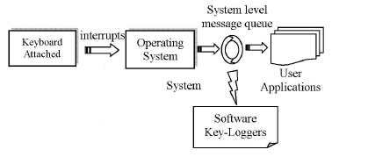

Figure 3.1: Project Architecture of key logger detection

**3.2 DESCRIPTION**

In this system, whenever a keyboard key is pressed a specific hardware interrupt is sent to the running system. This interrupt is received by the 'system level message queue' along with the specific 'key value'. System tracks the focused application at the time when the keyboard interrupt was generated and passes the key value to the 'application level message queue' of that specific focused application. Now it's the responsibility of that application to handle this key accordingly. If system does not find any specific focused application, it simply discards that key.

**3.3 USE CASE DIAGRAM**

In the use case diagram we have basically two actors who are the victim and the admin. The victim will press any key in keyboard that pressed keystrokes will saved to the log file and that log file can able see only by admin. This process is graphically explained in the Figure 3.3: Use Case Diagram for user for Key logger detection.

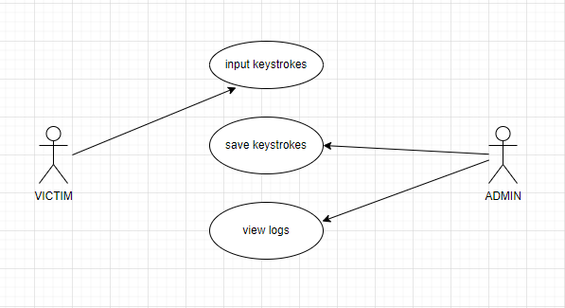

Figure 3.3: Use Case Diagram for user for Key logger detection

**3.4 SEQUENCE DIAGRAM**

The Figure 3.4: Sequence Diagram for Key logger detection is a graphical representation of the sequence of the operations performed by the victim input text using keyboard.

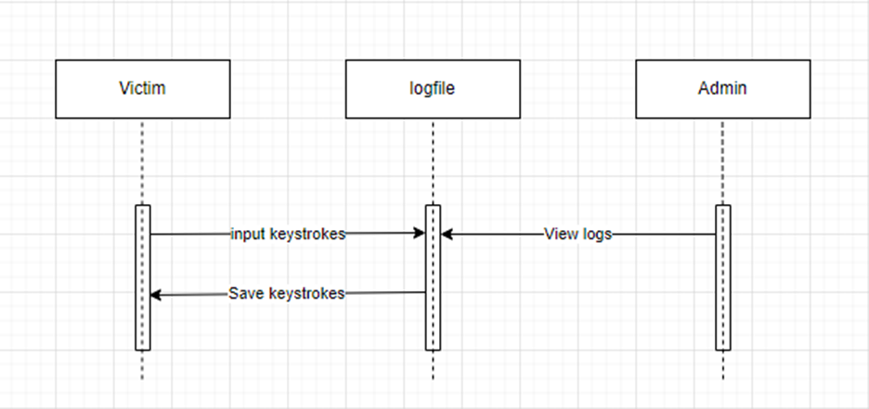

Figure 3.4: Sequence Diagram for key logger detection.

`**4. IMPLEMENTATION**

**4. IMPLEMENTATION**

**4.1 SAMPLE CODE**

#Importing listener from pynput.keyboard for reading input from keyboard

Key q pressed!

Key 'q' released

Key w pressed!

Key 'w' released

Special Key Key.shift pressed!

Key A pressed!

Key 'A' released

Key Key.shift released

Key a pressed!

Key 'a' released

Special Key Key.shift pressed!

Key A pressed!

Key 'A' released

Key Key.shift released

Special Key Key.shift pressed!

Key @ pressed!

Key '@' released

Key Key.shift released

Special Key Key.shift pressed!

Key $ pressed!

Key '$' released

Key Key.shift released

Special Key Key.shift pressed!

Key ) pressed!

Key ')' released

Key Key.shift released

Special Key Key.shift pressed!

Key > pressed!

Key '>' released

Key Key.shift released

Key . pressed!

Key '.' released

Special Key Key.esc pressed!

Key Key.esc released

**5. TESTING**

**5. TESTING**

**5.1 INTRODUCTION TO TESTING**

The purpose of testing is to discover errors. Testing is the process of trying to discover every conceivable fault or weakness in a work product. It provides a way to check the functionality of components, subassemblies, assemblies and/or a finished product. It is the process of exercising software with the intent of ensuring that the Software system meets its requirements and user expectations and does not fail in an unacceptable manner. There are various types of test. Each test type addresses a specific testing requirement.

**5.2 TYPES OF TESTING**

**5.2.1 UNIT TESTING**

Unit testing involves the design of test cases that validate that the internal program logic is functioning properly, and that program inputs produce valid outputs. All decision branches and internal code flow should be validated. It is the testing of individual software units of the application .it is done after the completion of an individual unit before integration. This is a structural testing, that relies on knowledge of its construction and is invasive. Unit tests perform basic tests at component level and test a specific business process, application, and/or system configuration. Unit tests ensure that each unique path of a business process performs accurately to the documented specifications and contains clearly defined inputs and expected results.

**5.2.2 INTEGRATION TESTING**

Integration tests are designed to test integrated software components to determine if they actually run as one program. Testing is event driven and is more concerned with the basic outcome of screens or fields. Integration tests demonstrate that although the components were individually satisfaction, as shown by successfully unit testing, the combination of components is correct and consistent. Integration testing is specifically aimed at exposing the problems that arise from the combination of components.

**5.2.3 FUNCTIONAL TESTING**

Functional tests provide systematic demonstrations that functions tested are available as specified by the business and technical requirements, system documentation, and user manuals. Functional testing is centred on the following items:

Valid Input : identified classes of valid input must be accepted.

Invalid Input : identified classes of invalid input must be rejected.

Functions : identified functions must be exercised.

Output : identified classes of application outputs must be exercised.

Systems/Procedures: interfacing systems or procedures must be invoked.

Organization and preparation of functional tests is focused on requirements, key functions, or special test cases. In addition, systematic coverage pertaining to identify Business process flows; data fields, predefined processes.

**5.3 TEST CASES**

**5.3.1 USER INPUT TEXT KEY**

|  |  |  |  |  |
| --- | --- | --- | --- | --- |
| Test case ID | Test case name | Purpose | Test Case | Output |
| 1 | User input text key(keystrokes) | Use it for saved in a log,txt | The user text in note pad. | Detected successfully |
| 2 | User input 2nd text key(project) | Use it for saved in a log.txt | The user text in google. | Detected successfully |

**6. SCREENSHOTS**

**6. SCREENSHOTS**

**6.1 INPUT TEXT KEY**

In the below screenshots we can see the input text key. The following screenshot 6.1 shows us where the user text key in google.

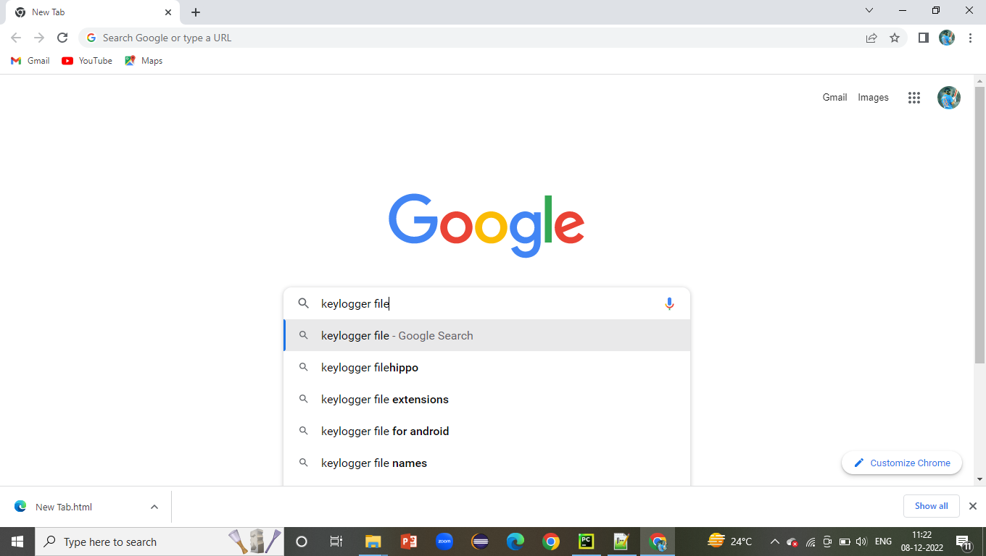

Screenshot 6.1: input text key in google

The following screenshot 6.2 shows us where the input text key stored in log .txt

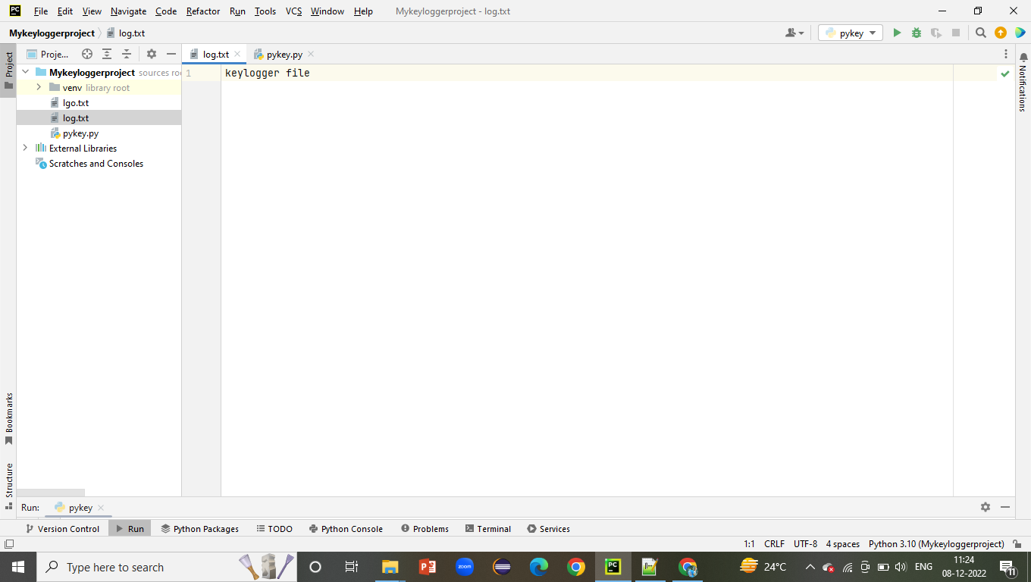

Screenshot 6.2: Key stored in log.txt

The following screenshot 6.3 In the below screenshots we can see the input text key. It shows us where the user text key in note pad.



Screenshot 6.3: Input text key in Note Pad

The following screenshot 6.4 shows us where input text key stored in log.txt

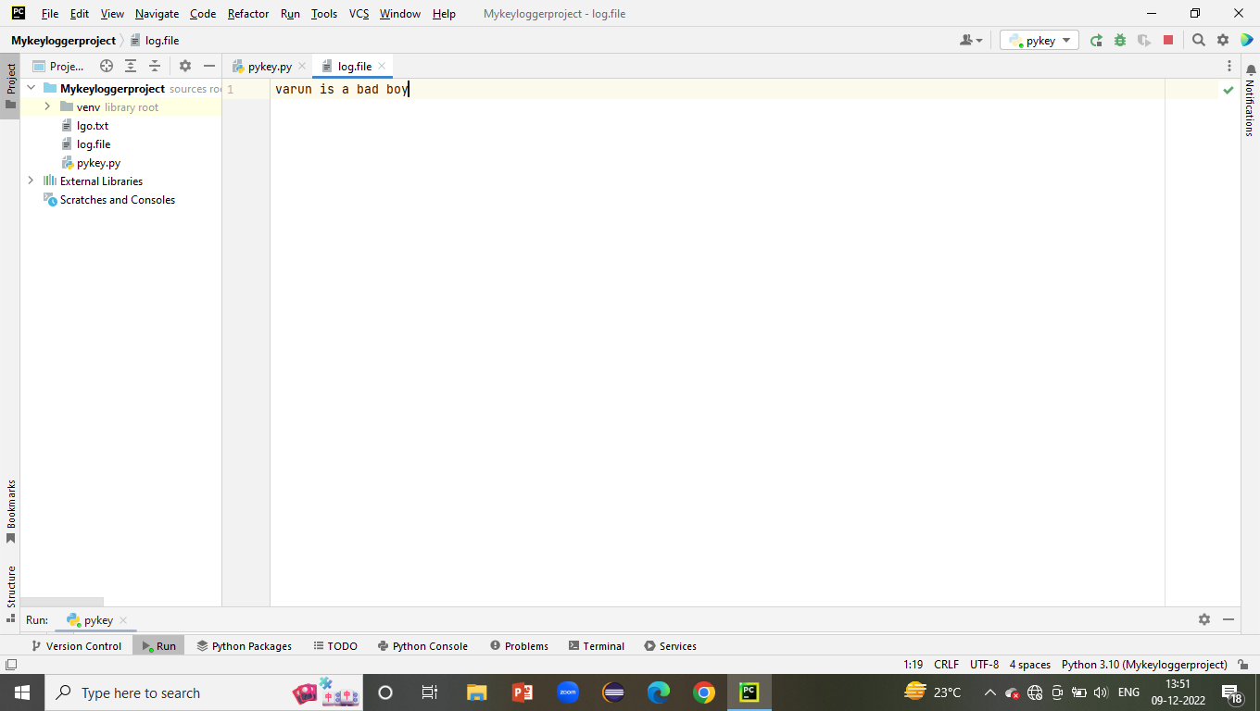

Screenshot 6.4: Key stored in log.txt

**7. CONCLUSION&FUTURE SCOPE**

**7. CONCLUSION & FUTURE SCOPE**

**7.1 PROJECT CONCLUSION**

The project titled as “Key logger detection” A Windows Pc on Keystroke analysis has been implemented successfully. The software is able to monitor data and store the data in a hidden log file that log file is being viewed by administrator only. The software is also able to hide itself from the owner if the system while it runs in background. Our final is result is a fully working key logger software with some features that will useful features that will show in our last presentation. we can a lot develop our project and we can fully swear that this program will be used only in legitimate ways.

**7.2 FUTURE SCOPE**

In future we extend to add certain extra features like saves screenshots at regular intervals and whenever mouse is pressed.

**8. BIBLIOGRAPHY**

**8. BIBLIOGRAPHY**

**8.1 REFERENCES**

1. <https://www.researchgate.net/publication/309230926_Survey_of_Keylogger_Technologies>
2. <https://www.researchgate.net/publication/228797653_Keystroke_logging_keylogging>
3. <https://en.wikipedia.org/wiki/Keystroke_logging>